**[04 - Iteration Control Structures](https://www.rajalakshmicolleges.net/moodle/course/view.php?id=84&section-4)**

**Ex. No. : 4.1 Date: 10.4.24**

**Register No.: 231501182 Name: vijay.m**

## [Factors of a number](https://www.rajalakshmicolleges.net/moodle/mod/quiz/view.php?id=5720)

Determine the factors of a number (i.e., all positive integer values that evenly divide into a number).

**For example:**

|  |  |  |
| --- | --- | --- |
| **Inpu t** | **Result** |  |
| 20 | 1 2 4 5 10  20 |  |

# Program:

k=int(input()) l=[]

for i in range(1,k+1): if(k%i==0):

l.append(i) for j in l:

print(j,end=' ')

# Output:

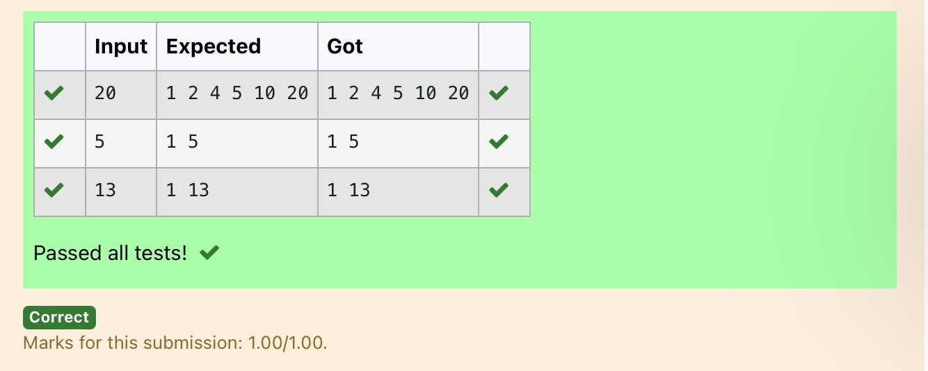

**Ex. No. : 4.2 Date: 10.4.24**

**Register No.: 231501182 Name: vijay.m**

## [Non](https://www.rajalakshmicolleges.net/moodle/mod/quiz/view.php?id=5717) Repeated Digit Count

Write a program to find the count of non-repeated digits in a given number N. The number will be passed to the program as an input of type int.

Assumption: The input number will be a positive integer number >= 1 and <= 25000. Some examples are as below.

If the given number is 292, the program should return 1 because there is only 1 non- repeated digit '9' in this number

If the given number is 1015, the program should return 2 because there are 2 non- repeated digits in this number, '0', and '5'.

If the given number is 108, the program should return 3 because there are 3 non- repeated digits in this number, '1', '0', and '8'.

If the given number is 22, the function should return 0 because there are NO non- repeated digits in this number.

**For example:**

|  |  |
| --- | --- |
| **Input** | **Resul t** |
| 292 | 1 |
| 1015 | 2 |
| 108 | 3 |
| 22 | 0 |

# Program:

n=int(input()) l=[]

k=[]

while n>0: a=n%10 n=n//10 l.append(a)

for i in range(len(l)): if l.count(l[i])==1:

k.append(l[i])

print(len(k))

# Output:

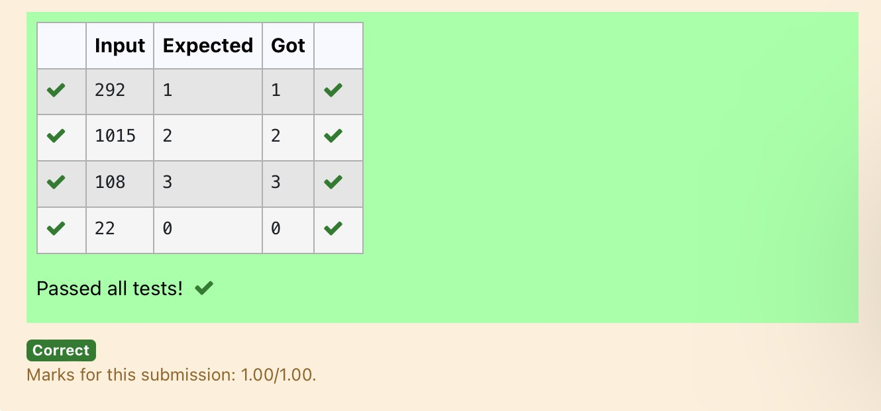

**Ex. No. : 4.3 Date: 10.4.24**

**Register No.: 231501182 Name: vijay.m**

## Prime Checking

Write a program that finds whether the given number N is Prime or not. If the number is prime, the program should return 2 else it must return 1.

Assumption: 2 <= N <=5000, where N is the given number. Example1: if the given number N is 7, the method must return 2 Example2: if the given number N is 10, the method must return 1

**For example:**

|  |  |
| --- | --- |
| **Input** | **Result** |
| 7 | 2 |
| 10 | 1 |

# Program:

a=int(input())

for i in range(2,a): if(a%2==0):

flag=0 elif(a%i!=0): flag=1

else:

flag=0 if(flag==1):

print("2") elif(flag==0):

print("1")

# Output:

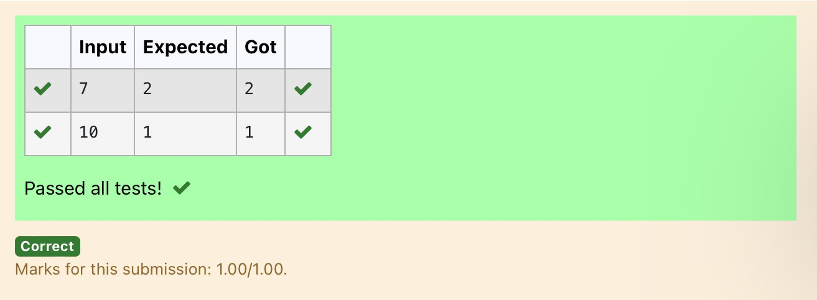

**Ex. No. : 4.4 Date: 10.4.24**

**Register No.: 231501182 Name: vijay.m**

## Next Perfect Square

Given a number N, find the next perfect square greater than N. Input Format:

Integer input from stdin. Output Format:

Perfect square greater than N. Example Input:

10

Output:

16

# Program:

a=int(input()) c=[]

for i in range(0,a): b=i**2

if(b>a):

c.append(b) print(c[0])

# Output:

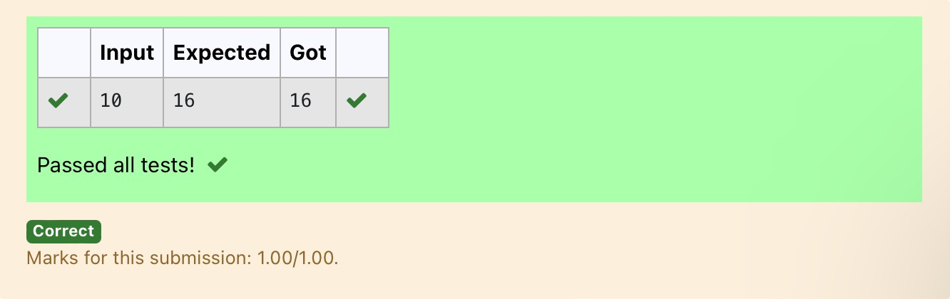

**Ex. No. : 4.5 Date: 10.4.24**

**Register No.: 231501182 Name: vijay.m**

## Nth Fibonacci

Write a [program](https://www.rajalakshmicolleges.net/moodle/mod/quiz/view.php?id=3478) to return the nth number in the fibonacci series. The value of N will be passed to the [program](https://www.rajalakshmicolleges.net/moodle/mod/quiz/view.php?id=3478) as input.

NOTE: Fibonacci series looks like –

0, 1, 1, 2, 3, 5, 8, 13, 21, 34, 55, . . . and so on.

i.e. Fibonacci series starts with 0 and 1, and continues generating the next number as the sum of the previous two numbers.

* first Fibonacci number is 0,
* second Fibonacci number is 1,
* third Fibonacci number is 1,
* fourth Fibonacci number is 2,
* fifth Fibonacci number is 3,
* sixth Fibonacci number is 5,
* seventh Fibonacci number is 8, and so on.

**For example:**

**Input:**

**7**

**Output 8**

# Program:

a=[0,1]

for i in range(0,100): a.append(a[-1]+a[-2])

q=int(input()) print(a[q-1])

# Output:

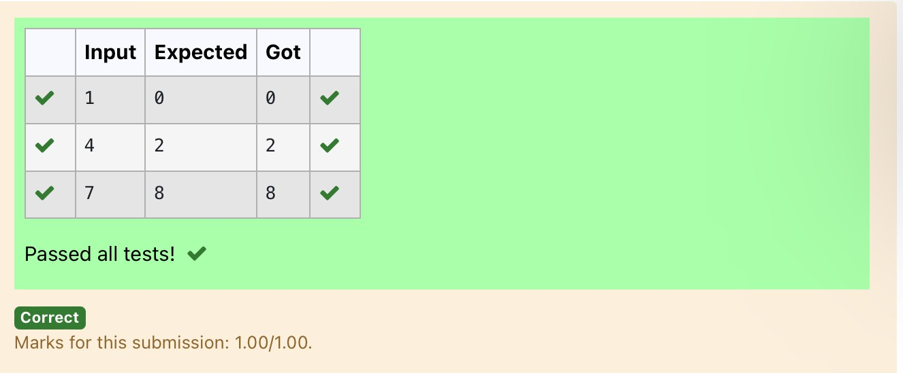

**Ex. No. : 4.6 Date: 10.4.24**

**Register No.: 231501182 Name: vijay.m**

## Disarium Number

A Number is said to be Disarium number when the sum of its digit raised to the power of their respective positions becomes equal to the number itself. Write a [program](https://www.rajalakshmicolleges.net/moodle/mod/quiz/view.php?id=3478) to print number is Disarium or not.

Input Format:

Single Integer Input from stdin. Output Format:

Yes or No.

Example Input:

175

Output:

Yes Explanation

1^1 + 7^2 +5^3 = 175

Example Input: 123

Output:

No

**For example:**

|  |  |
| --- | --- |
| **Inp ut** | **Res ult** |
| 175 | Yes |
| 123 | No |

import math

# Program:

n=int(input()) a=len(str(n)) sum=0

x=n while(x!=0):

r=x%10 sum=int(sum+math.pow(r,a)) a-=1

x=x//10 if(sum==n):

print("Yes") else:

print("No")

# Output:

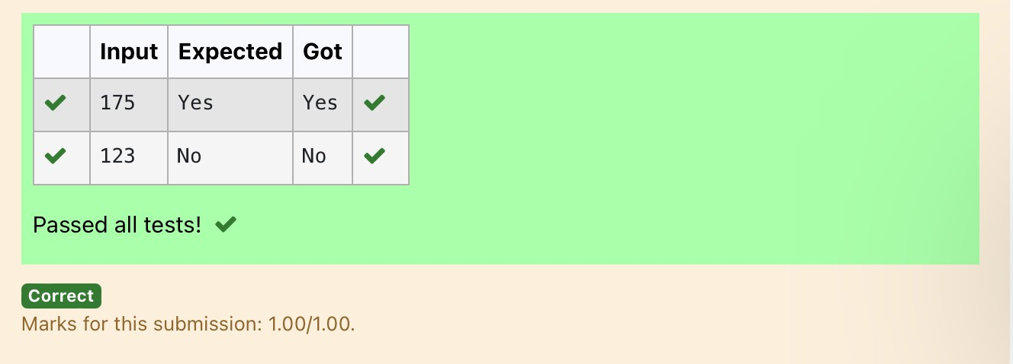

**Ex. No. : 4.7 Date: 10.4.24**

**Register No.: 231501182 Name: vijay.m**

## Sum of Series

Write a program to find the sum of the series 1 +11 + 111 + 1111 + . . . + n terms (n will be given as input from the user and sum will be the output)

Sample Test Cases Test Case 1

Input 4

Output 1234

Explanation:

as input is 4, have to take 4 terms. 1 + 11 + 111 + 1111

Test Case 2 Input

6

Output 123456

**For example:**

|  |  |
| --- | --- |
| **Input** | **Result** |
| 3 | 123 |

# Program:

n=int(input()) b=1

sum=0

for i in range(1,n+1):

sum+=b b=(b*10)+1

print(sum)

# Output:

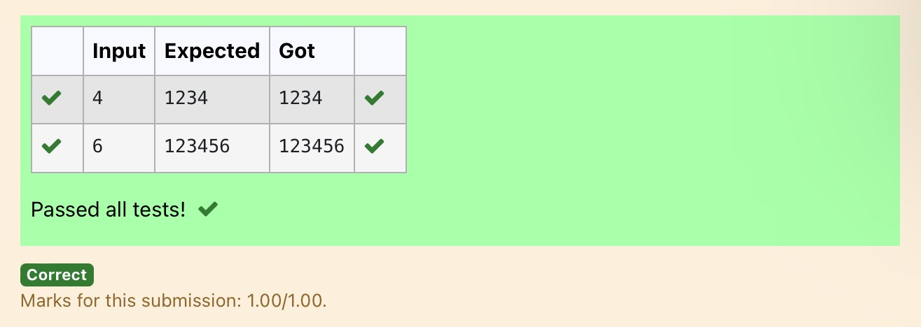

**Ex. No. : 4.8 Date: 10.4.24**

**Register No.: 231501182 Name: vijay.m**

## Unique Digit Count

Write a program to find the count of unique digits in a given number N. The number will be passed to the program as an input of type int.

Assumption: The input number will be a positive integer number >= 1 and <= 25000. For e.g.

If the given number is 292, the program should return 2 because there are only 2 unique digits '2' and '9' in this number

If the given number is 1015, the program should return 3 because there are 3 unique digits in this number, '1', '0', and '5'.

**For example:**

|  |  |
| --- | --- |
| **Input** | **Result** |
| 292 | 2 |
| 1015 | 3 |

# Program:

a=int(input()) b=[]

while a>0: c=a%10 a=a//10 b.append(c)

b=list(set(b)) print(len(b))

# Output:

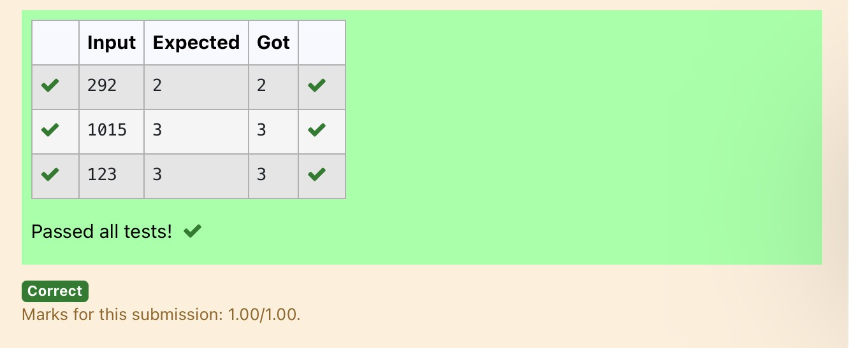

**Ex. No. : 4.9 Date: 10.4.24**

**Register No.: 231501182 Name: vijay.m**

## Product of single digit

Given a positive integer N, check whether it can be represented as a product of single digit numbers.

Input Format:

Single Integer input.

Output Format:

Output displays Yes if condition satisfies else prints No. Example Input:

14

Output:

Yes

Example Input: 13

Output:

No

# Program:

a=int(input()) flag=0

for i in range(10): for j in range(10):

if(i*j==a): flag=1 break

if(flag==1): print("Yes")

else:

print("No")

# Output:

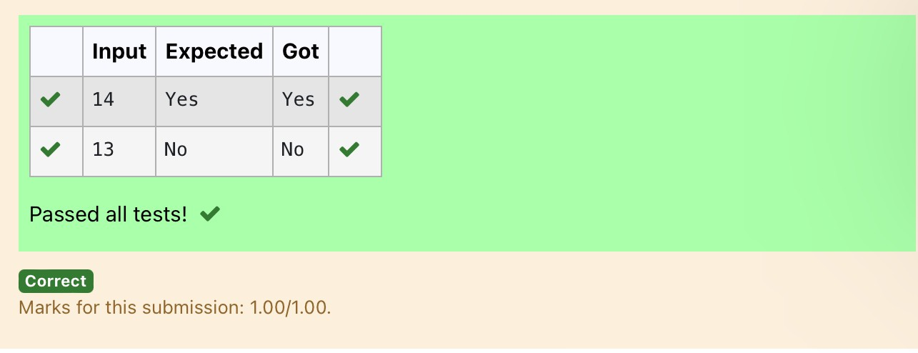

**Ex. No. : 4.10 Date: 10.4.24**

**Register No.: 231501182 Name: vijay.m**

## Perfect Square After adding One

Given an integer N, check whether N the given number can be made a perfect square after adding 1 to it.

Input Format: Single integer input. Output Format:

Yes or No.

Example Input:

24

Output:

Yes

Example Input: 26

Output:

No

**For example:**

|  |  |
| --- | --- |
| **Input** | **Resul t** |
| 24 | Yes |

# Program:

import math n=int(input()) a=n+1 sr=int(math.sqrt(a))

if(sr*sr==a): print("Yes")

else:

print("No")

Output:

